*Integrating Checkmarx with TeamCity*

*(Version 7.2.3 – December 2015)*

**Summary**

The purpose of this document is to explain how to run a Checkmarx scan from an existing TeamCity build server. Checkmarx will scan the source code that is within the job’s workspace and return a result status and reports to TeamCity.

The Checkmarx scan is configured as a TeamCity build step that executes a windows batch script. The script used, Checkmarx_scan_TeamCity.bat (provided by Checkmarx), will zip the source code that is in the project’s workspace and will send it to the Checkmarx server for scanning. At the end of the scan Checkmarx will create pdf and xml reports of the scan and return a status of Success or Failure.

**Prerequisites**

1. You should have the Checkmarx Integration Kit - CxConsole_TeamCity.zip archive (embedded here). 
2. Java must be installed on the Continuous Integration Server (JDK or JRE). Java JDK or JRE can be downloaded from Oracle at: <http://www.oracle.com/technetwork/java/javase/downloads/index.html>

**Steps to configure**

1. You should unzip the CxConsole_TeamCity.zip archive and place it on the TeamCity Server in any folder.

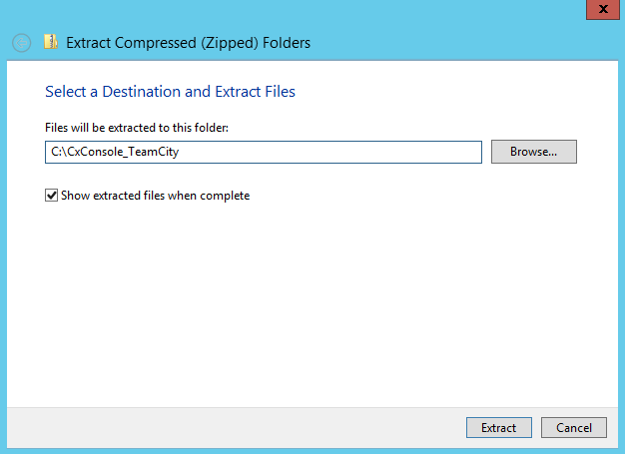

The folder contents should look more or less like this:

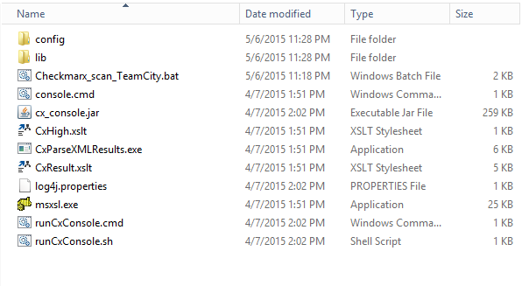

1. Edit file Checkmarx_scan_TeamCity.bat, set the following parameters and Save the changes:

**JAVA_HOME** – the location of your JRE or JDK.

**CX_CONSOLE_PATH** - the location to which you unzipped the CxConsole_TeamCity package.

**USERNAME** - the Checkmarx user account that will be used for the scan.

**PASS** – the user’s password.

**CHECKMARX_HOST** - the name or ip address of the Checkmarx Server.

**PRESET** - the Checkmarx preset that you would like to scan with.

**TEAMCITY_WORKSPACE** - the path to the directory that stores the project's source code.

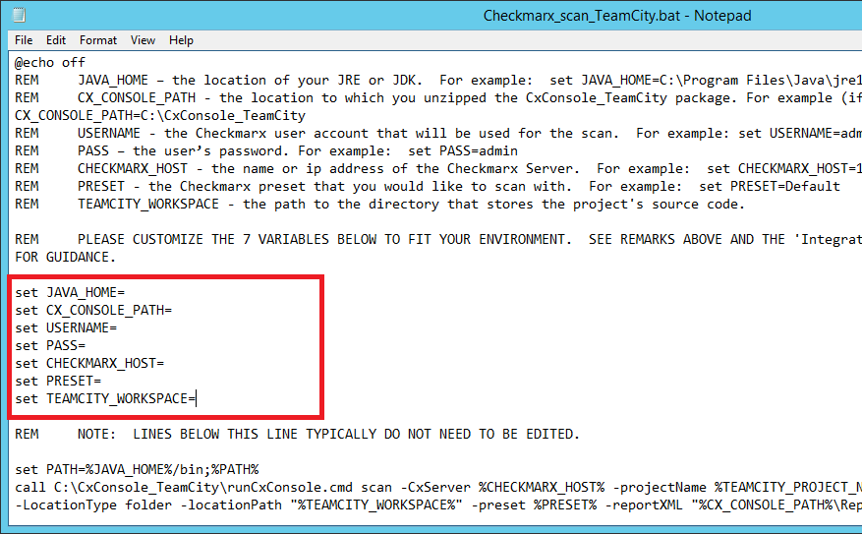

1. Within your TeamCity Project(s), click “Edit Project Settings”.

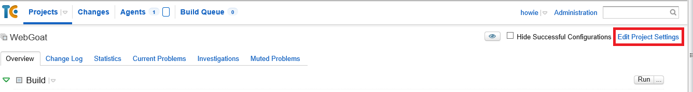

1. Under “Build Configurations”, click “Edit”

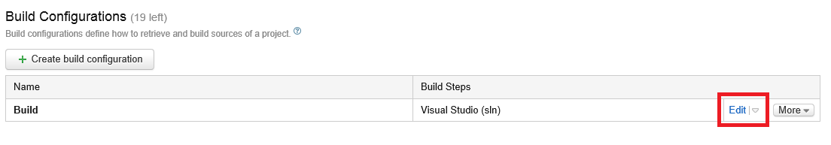

1. In the “Artifacts” textbox, type the path to where you unzipped the CxConsole_TeamCity.zip package + “\Reports\*CXresults”.

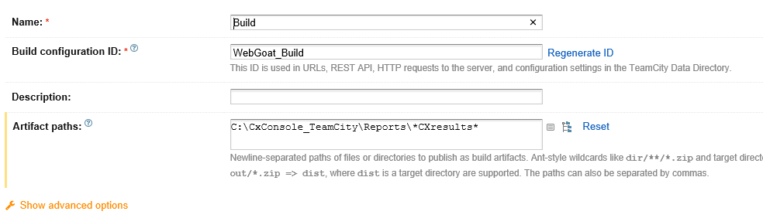

1. Next, click “Build Step” in the navigation menu.

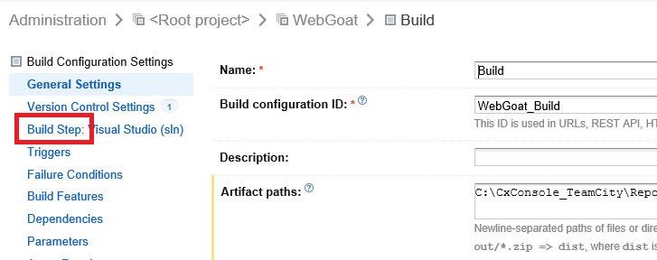

1. Under “Build Step”, click the “Add Build Step” button.

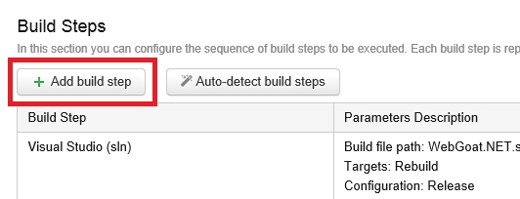

1. In the “New Build Step: dialog:
   * Select “Command Line” from the Runner type dropdown menu.
   * Type in a value for Step name (ie: Checkmarx Scan).
   * Select “Custom script” from the “Run” dropdown menu.
   * In the “Custom script” text field, type the path to the “Checkmarx_scan_TeamCity.bat” batch file.
   * Click the “Save” button.

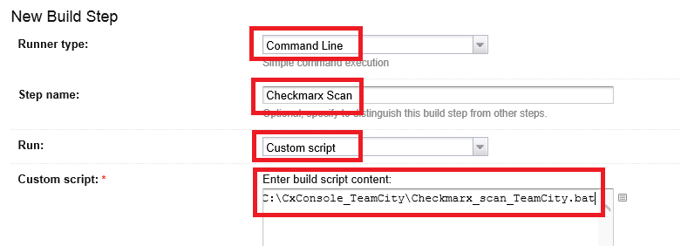

**Sample Output**

During a Build, you can view the console output showing the project execution details.

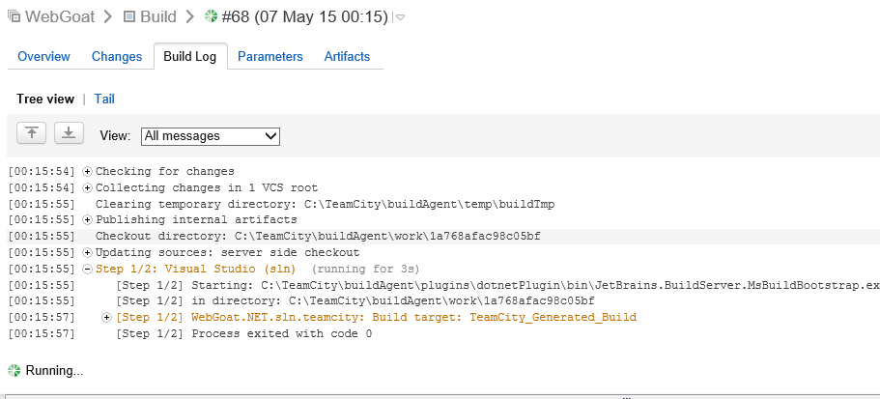

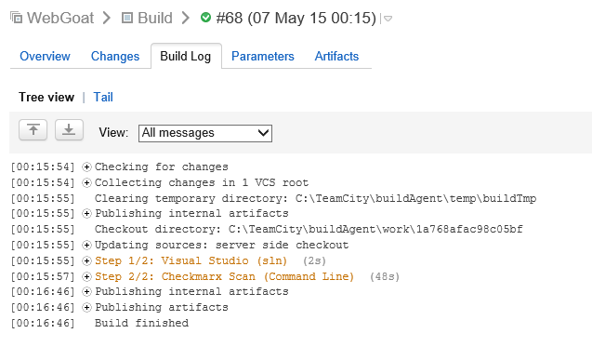

As a result of specifying an Artifacts path (in step #5 above), you’ll have access to the PDF and XML reports directly from within the build’s Artifacts tab.

